Hyoungjun Lee  
Project A3/ gitter-geeks  
ARM_Assembly_Programming_A3  
3/5/2020  
Computer Org & Programming

**Task A)**

* What error message did you get and why? (Report that)

We found .shalfword error in the third.s

Why?

Shalfword cannot be a data declaration

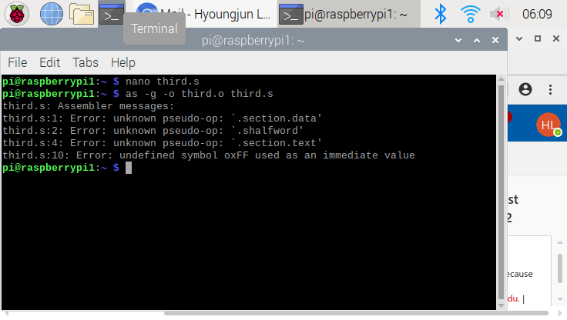

after correction the declaration variable type to .word, the code assembled correctly

As shown below picture,

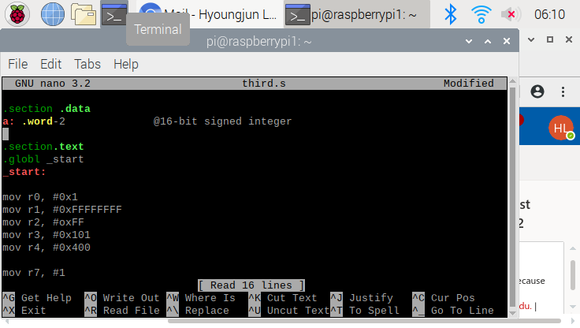

as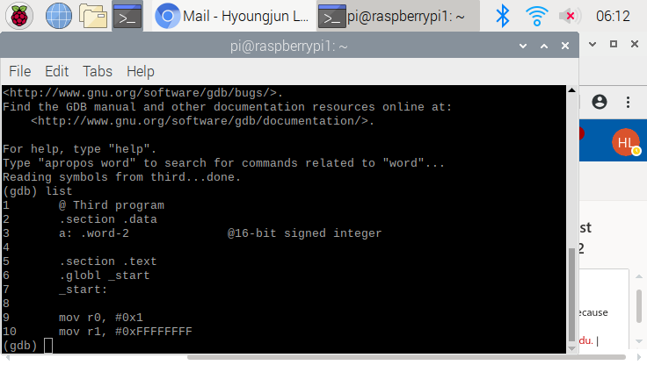

and we set up the break point at line 7, but it moved to line 10 automatically, we tried to test register or memory by using (gdb) x/1xh 0x10078.

Pictures below

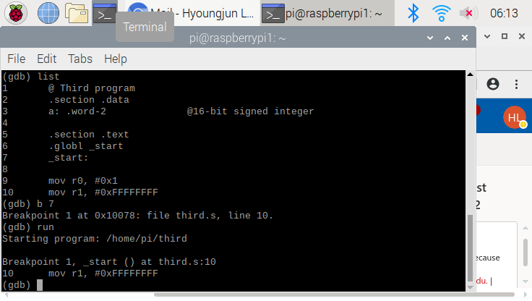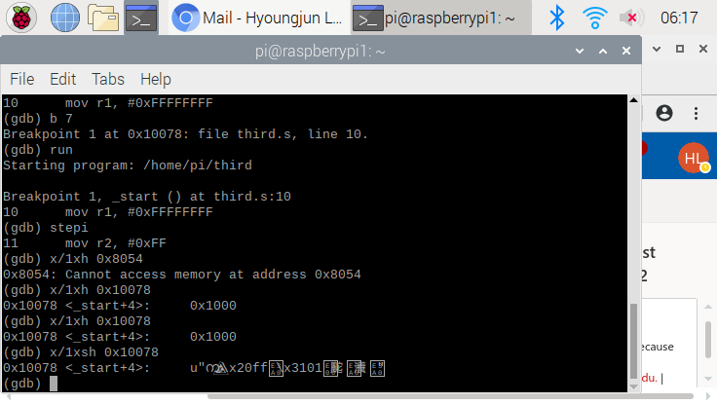

With xh(unsigned) and xsh(signed), we got same offset <_start+4> but for the address,

I cannot define sign value’s address

**Task B)**

Register = val2 + 3 + val3 – val1; val1 = -60(signed), val2 = 11(unsigned), and val3 = 16(unsigned) and all these memories are 8-bit integer memory

I wrote code to calculate the equation above

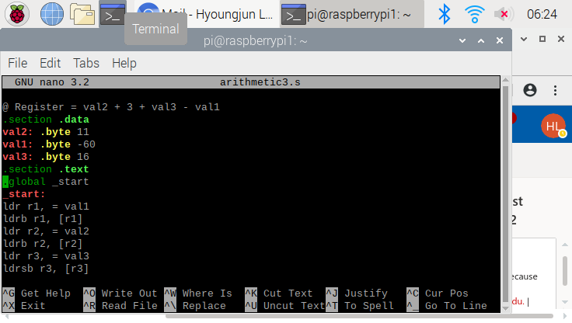

Then we assembled and linked together and ran it, picture is below

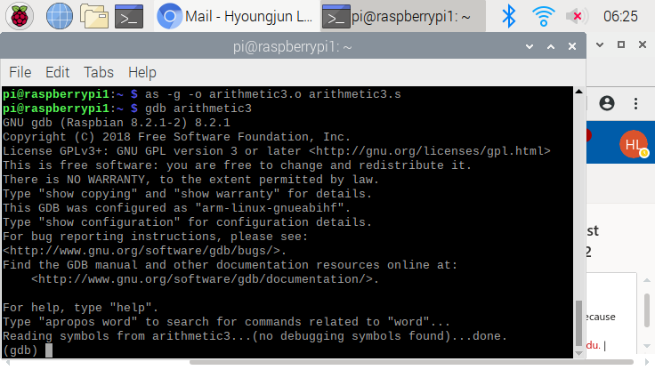

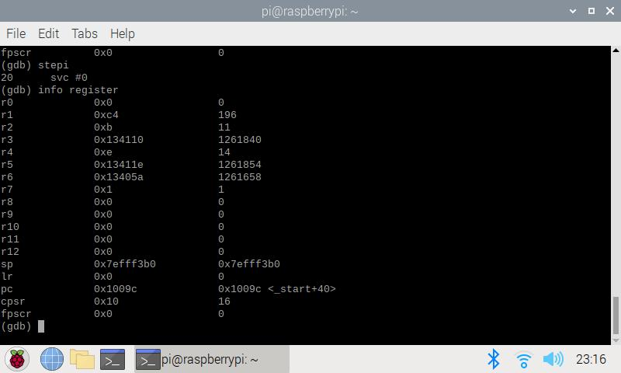

With the assigned value, we know register would be 90

11+3+16-(-60) = 90.

r1 = C4h which corresponds to -60 (11000100) that is our Val1

r2 = 0Bh which corresponds to 11 that is our val2

r3 = 10h which corresponds to 16 that is our val3

similarly

r4 = 14

r5 = 30

r6 = 90 (5a) which is our final answer of the “Register”

when we check “cpsr” value, negative value is set

all these values are expected.